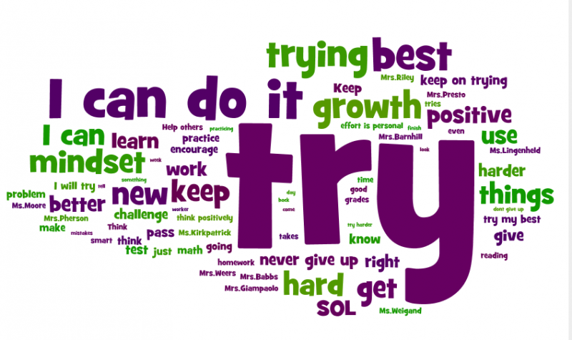
Ms. Hewitt’s First Grade Syllabus
Triad Math and Science Academy
2018-2019 School Year

Class Description:
Language Arts: In First grade, students are extending their understanding of the skills of phonemic awareness and decoding and word recognition. They are also extending their comprehension and use of conventions for written language. Students read a variety of texts, listen to literature, and respond to books, poetry, plays, age-appropriate expository texts, environmental print, and self-selected reading materials. They expand their oral language skills and their knowledge about recording oral language to express themselves clearly. As they participate in discussing texts and constructing texts, they expand their store of words. They begin to use new vocabulary and formats for their written products as a result of their examination of models of speaking and writing. First grade students will: read a variety of texts in different settings, respond to texts in different ways, use conversational and literary language to express themselves, and begin to develop effective listening and speaking skills. Text used: Reading Wonders.
Math: Goals and major concepts/skills for the First Grade Math Curriculum: number sense 0-200, single and double digit addition and subtraction, time, standard measurement, fractions, collecting and displaying data, basic geometric 2D and 3D shapes, Text used: My Math series.
Science: The focus for First Grade students is on exploring the world around them with a use of the Scientific Method. The observations that students make, provide evidence and data on which to base their scientific explanations and guide student learning of all goals on the unifying concepts of evidence, explanation, and measurement. Themed units of Weather, Solids and Liquids, Comparing and Measuring, and Organisms will be used.
Social Studies: Students continue to develop concepts, generalizations, and skills introduced in kindergarten as they learn about their neighborhood and community, and extend their knowledge of others throughout the world. They examine a variety of neighborhoods and recognize the multiple roles of individuals and families. Students explore characteristics of the local government while expanding their understanding of justice, authority, and responsibility. They analyze and evaluate the effects of change and become more aware of diversity and cultural traditions throughout communities. Goals in First Grade focus on cultures and diversity, community and rules, geographic relationships, economics and development, government, and citizenship.

Behavior Plan

Student Expectations: Students will gain self-independence through being responsible for their own behavior, completing work, and showing respect for adults and other students with a ‘can do’ attitude.
Behavior and Discipline: Our school-wide Code of Conduct is always in place (Refer to your child’s TMSA Student Handbook and my welcome packet).
Classroom Rules: I have high expectations for all students. Having a safe, orderly, welcoming classroom is my goal. Students are expected to:
- Raise their hands for permission to speak or leave their seat.
- Follow directions quickly.
- Work hard and be respectful of others.
- Keep their hands, feet, and objects to themselves.
- Have fun and learn!
Communication: Behavior concerns will be communicated via phone calls or texts, emails and/or notes in the homework binder. At some point in the year, I may also use Class Dojo. Please make sure that you seriously address behavior concerns so that they do not cause disruption to class time. Please make sure to accept invitations or sign up for Remind to get text messages from me.

Other Important Information
Teacher/Parent Communication: We as teachers, at TMSA, strive to maintain an open line of communication. Please take care to give special attention to these communications. They may be in the form of:
- Weekly Newsletters; including news, important dates, reminders, and announcements.
- Daily communication: Please check your child’s book bag or binder for any papers that I may send home or notes from me.
- Wednesday Folder: includes graded work. Please review it and return empty folder.
- Class Dojo notifications.
- Progress Reports and Report Cards.
- Emails: Responses within 24 hours, including weekends. If you have homework questions, texts are better.
- By phone: Calls will be returned within 48 hours.
- Parent-Teacher Conferences: Two per year (One Fall and one Spring); Additional conference requests may also be communicated, if necessary.
Homework: Homework is an important part of ensuring your child has a successful school year. It enables your child to independently practice what was learned in school. Parents are welcome to help guide their child in their homework but please, only do so when your child is stuck. Homework will be given on Monday and should be returned completed on Friday. Please ensure that your child keeps up with practice of the spelling words in readiness for the spelling test on Friday. Homework will be counted as part of your child’s grade. No homework will be given on Fridays unless it is make-up work or a family project.
Reading Log: Reading is the most important skill and especially for First Grade students. It is important for them to practice and use the reading skills they are learning in class. The Reading Log is essential. Students are encouraged to read every day, including reading aloud to a parent or guardian.
Morning Meeting and Snack Time: Morning meeting will begin right after morning announcements at 7:45am. This brief time will enable us to set the tone for the day with our Growth Mindset lessons. It is important for all students to be on time to participate in the learning activities that go along with this discussion. Having snack time is a privilege, not a requirement. Your child can bring one snack to eat prior to dismissal at the end of the day, somewhere around 2:10-2:15. In some cases, I will have snack on hand in case someone forgets, or parents may donate for the class. I may not always have time to check supplies and purchase more before running out so it is safer for your child to have their own snack prepared.
Absences and Make-up Work: Upon returning to school following an excused absence, students will receive any make-up work to be completed. Students have 3 days to complete any make up assignments for each day missed. For example, if a child is absent 2 days, they have 6 days to complete the make-up work as well as current assignments.

Grading System
First Grade uses a numerical grading system, 1-4. We do not give letter grades.
Numerical grades are determined according to weekly and quarterly tasks and assessments. Occasionally, 4s are earned. Please look at your child’s graded work sent home in the Wednesday folder so you are aware of when unsatisfactory or needs improvement work has been completed by your child. There should be no surprises at report card time if you are in contact with me, assisting or reviewing your child’s homework and reviewing graded work sent home.
- Outstanding 2. Satisfactory 3. Needs Improvement. 4. Unsatisfactory.

All classroom accommodations listed within the Individualized Education Plan (IEP) for students with disabilities will be adhered to.

***Please read the First Grade Syllabus, sign and return the following contract. Thank you for your support at TMSA!

Please sign and return this form by
August 24th, 2018

I read and understand Ms. Hewitt’s First Grade syllabus for the 2018-2019 school year. I understand that I am required to read all communication sent from Ms. Hewitt and TMSA in order to respond in an appropriate and timely manner, and provide support for my student.

My child will have access to the internet in order to complete some homework assignments
Yes_____ No____

I approve of the use of photographs of my child on Ms. Hewitt’s website or the school website.

Yes _____ No _____

Signature _______________________________________________
Printed Name ____________________________________________
Child’s Name _____________________________________________

